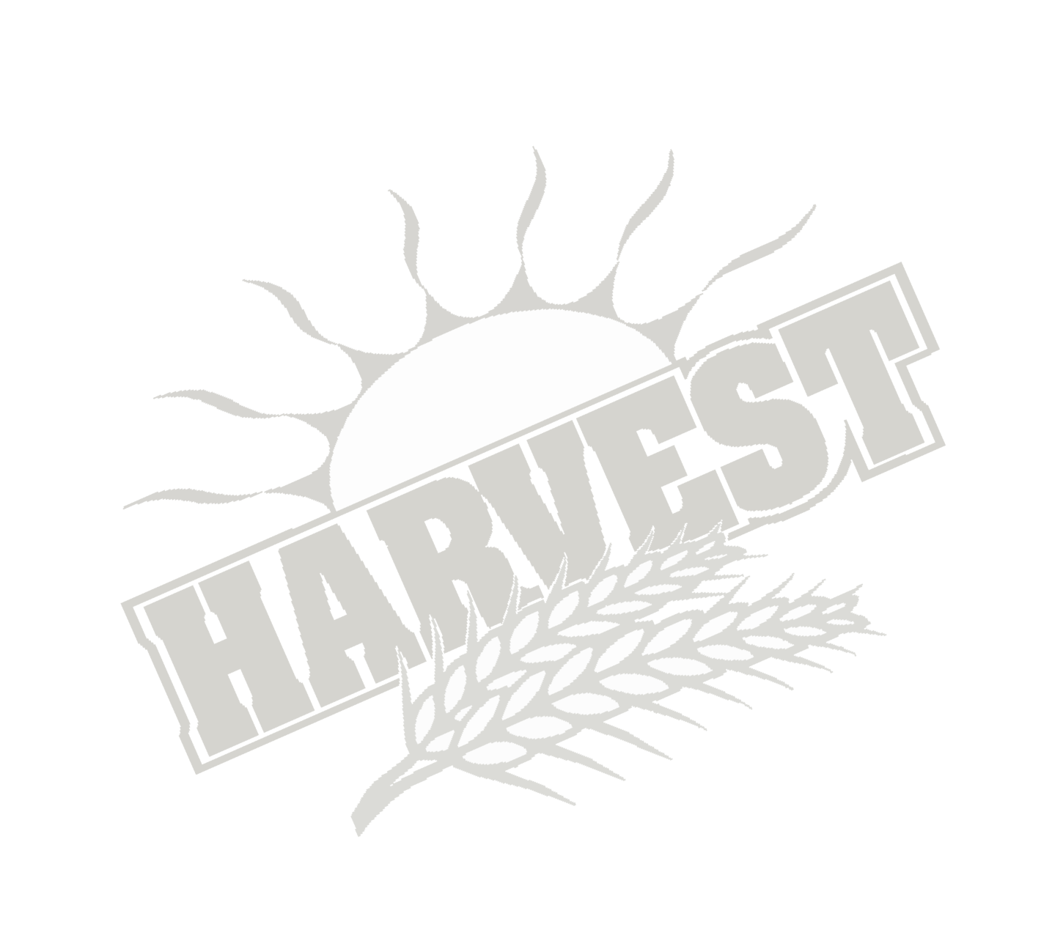
This is the Season of Sacrificial Sowing for the CT Church. Ecclesiastes chapter 3 says that God has ordained seasons and times in the earth for the benefit of his children. Jeremiah 1:10 tells us that the Lord reserves the right to either uproot a season, tear down during a season, destroy within a season, may overthrow, build or most important plant.

Our Senior Pastor, Rev. Don Nordin, has positioned us to see the hand of favor in the area of sustenance and survival! On Sunday, December 3rd, we will have HARVEST Sunday! This is the time of the year that we are encouraged to sow into a portal of expectation that, by faith, could change the very course of our current existence. St. John 5:4 teaches us that at a certain season, an angel of the Lord went down at certain seasons into the pool and stirred up the water and all who stepped in were made whole from whatever lack, shortage, or sickness with which he was afflicted!

My beloved, this is not about monetarily advancement. It’s reaching a place of wholeness in any area of your life that has lack, shortage and sickness. This is your season to sow into your very change. Where do I get the Seed to Sow? 2 Corinthians 9:10-15, teaches us that the Lord not only supplies “Seed to the Sower” but also SUPPLY and INCREASE your Storehouse by enlarging your Harvest! WOW!

Well Pastor Mike, why should I believe the man of God that any of this will come true? Well, 2 Chronicles 20:20 tells us that when we believe in Yahweh our God, we shall be established; and to believe the Prophetic Statements of his Prophets, earthen mouthpieces, you shall have great success! Remember, Sunday, December 3rd is just another opportunity to test God’s ability to bless you beyond and above what you will expect him to do.

This is what I am asking you to Do: (Before Harvest Week)
- Set Aside a Time to Pray to Receive an Amount to Sow – 1 Chronicles 14:14
- Set a Fast of 12 Hours for an Increase of Faith – St, Luke 17:7
- Sit in Silence and Ask God for ALL you Desire – 1 Kings 3:10

We are believing that 2018 will be the Year of Unexpected Blessings for Your Life! Lastly, I want you to write “LUKE 6:9 BLESSING” on your Envelope! The bible says after they had obeyed the opportunity of the man of God, that overflow began to overtake them to the point they had to give much of the blessings away to keep from drowning in it! IT’S HARVEST TIME!!!

